**JM CANTY**

**Buffalo, NY USA Dublin, Ireland**

**Color / Black Spec Detection - Rubber**

1. **Abstract**

Many products require quality inspection for uniformity of color or absence of defect particles. Plastics and rubber, for instance, require removal of dissimilar particles in order to prevent the outcomes of further processing and finishing operations from drifting outside the allowed deviations in whiteness or color. Vision, by operator or instrument, is the only way to accomplish this inspection and removal. Additionally, end products, such as sugar, must meet whiteness specifications and be free of dark specs of burnt sugar or other contamination in order to meet the consumer’s expectations. Canty offers solutions for these varied applications by combining quality software with proper hardware configurations that enable a high sensitivity in detecting out of spec particles. This paper will discuss rubber crumb in particular.

**Rubber Particles**

1. Requirement - as the rubber particles are manufactured they are visually inspected for defects which are non-white particles or particle surface defects. These particles are rather large and are usually transported on a conveyor on which they can be viewed and analyzed. A typical image of particles on a vibratory conveyor is shown in Figure 1.

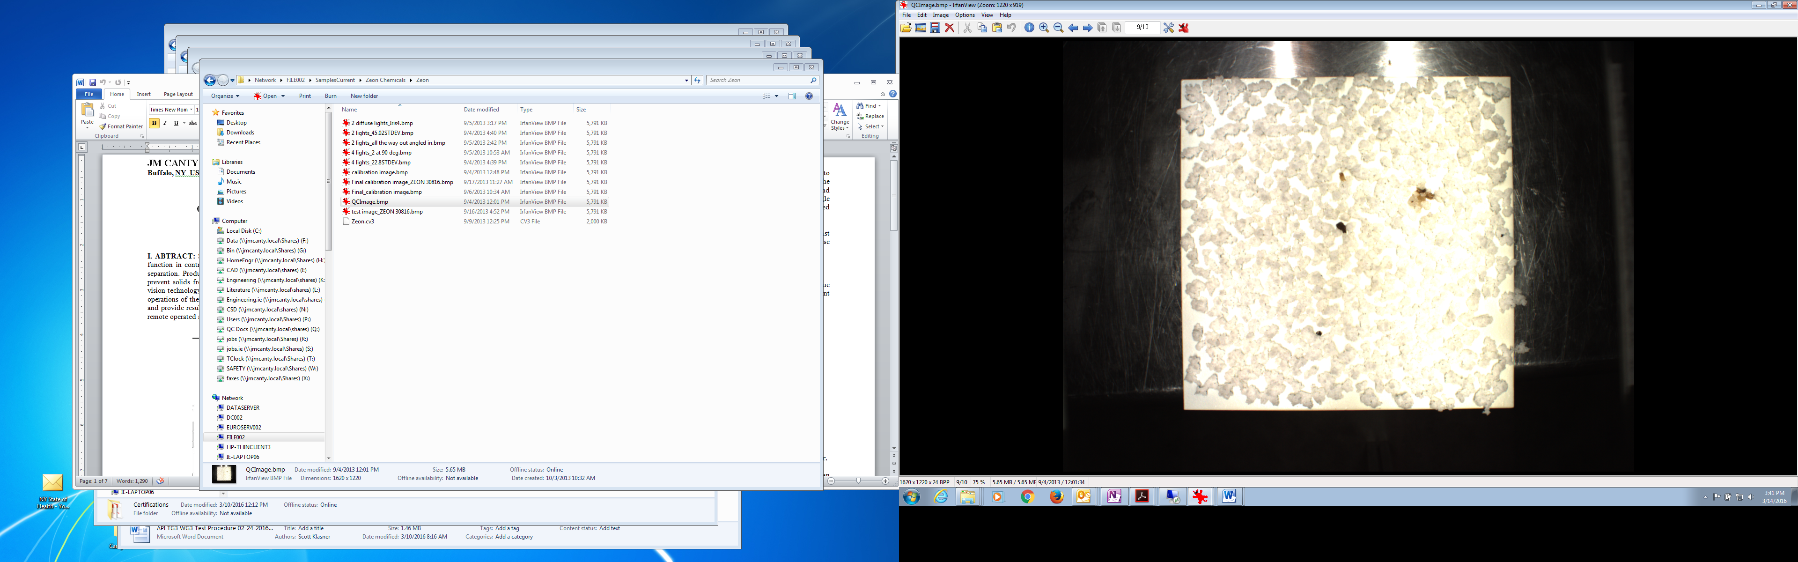

**Figure 1. Rubber Particles on a Conveyor.**

1. Application – as the particles move down the conveyor they pass under the camera view which is illuminated to eliminate shadows, which can be confused for defect particles, and to enhance the difference between good particles vs defect particles. A typical set up is depicted in Figure 2.

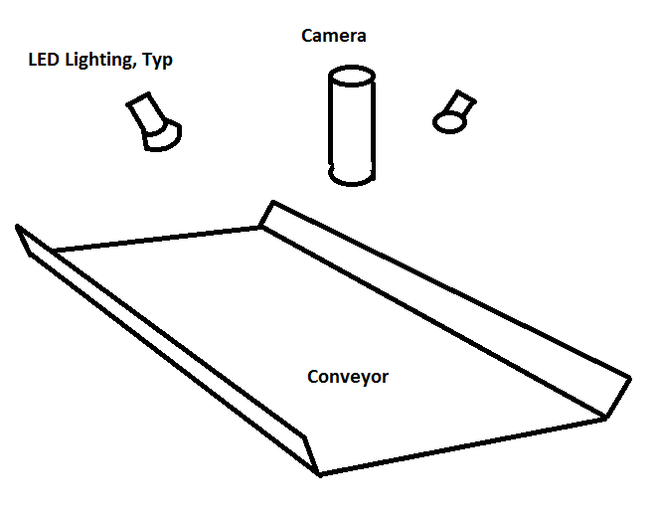

**Figure 2. Typical System Configuration.**

An actual set up of the camera and lights is shown in Figure 3 which has a central camera position flanked by two rail lights. Controlling the illumination is of primary importance in achieving a successful measurement. Differences in remaining shadows and defect specs can be quite small. Variations in the illumination with respect to space and time will cause for false positive readings.

The software analyzes the camera image and detects particles that qualify as dark specs and posts those results. The detected area is in many cases the best way to report these detections since some of the harder to see particles are a broken detection pattern. Figure 4 and 5 show typical crumb rubber visuals. Figure 6 shows a typical output on the user interface.

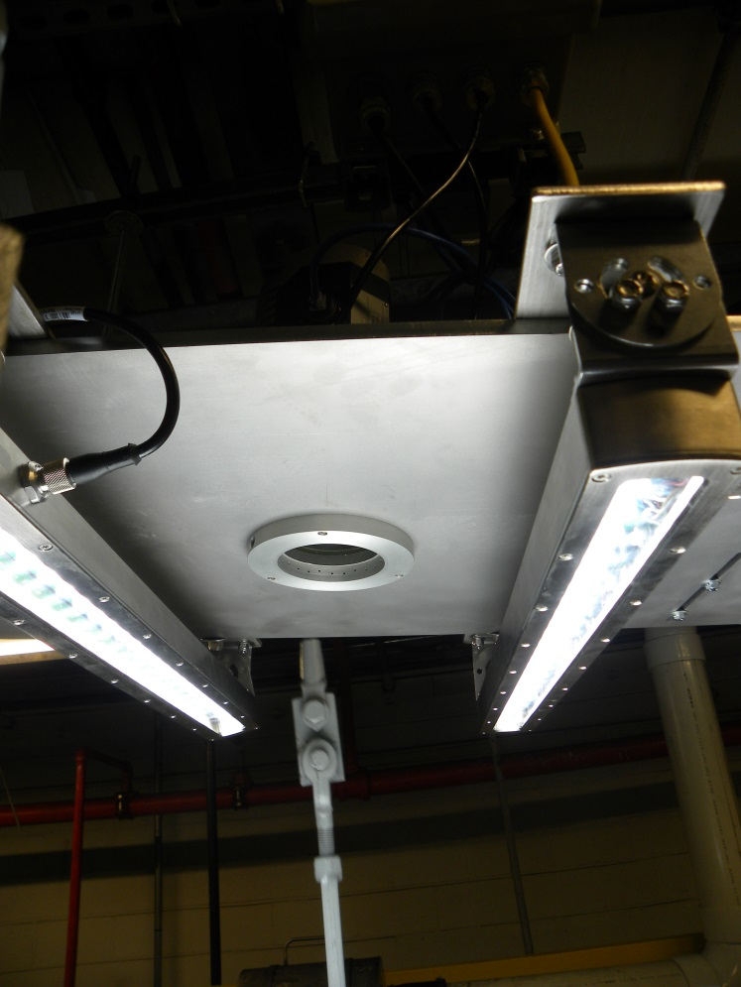

Figure 3. Camera / Light Overhead Assembly.



Figure 4. Rubber on a Conveyor.

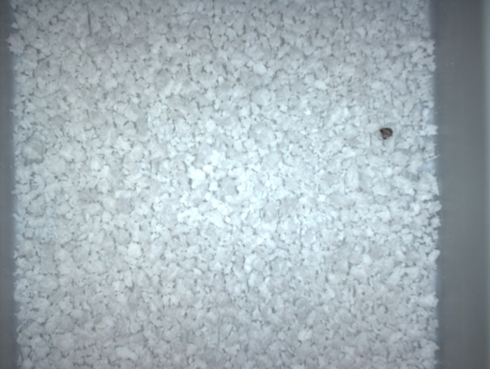

Figure 5. Rubber on a Conveyor.

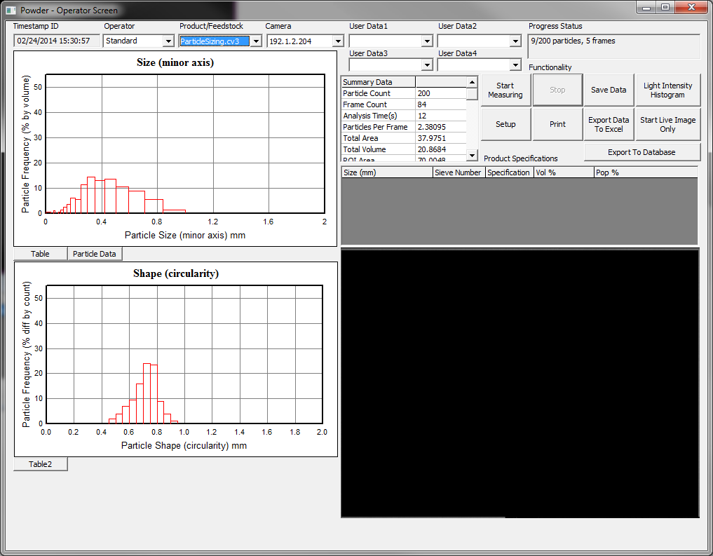

Figure 6. User Interface – Particle Count / Area

The next few images show the types of particles that are scanned for. These indicate that the detection is not always straightforward, but with proper set up and control of the measurement zone the goal can be accomplished with excellent consistency.

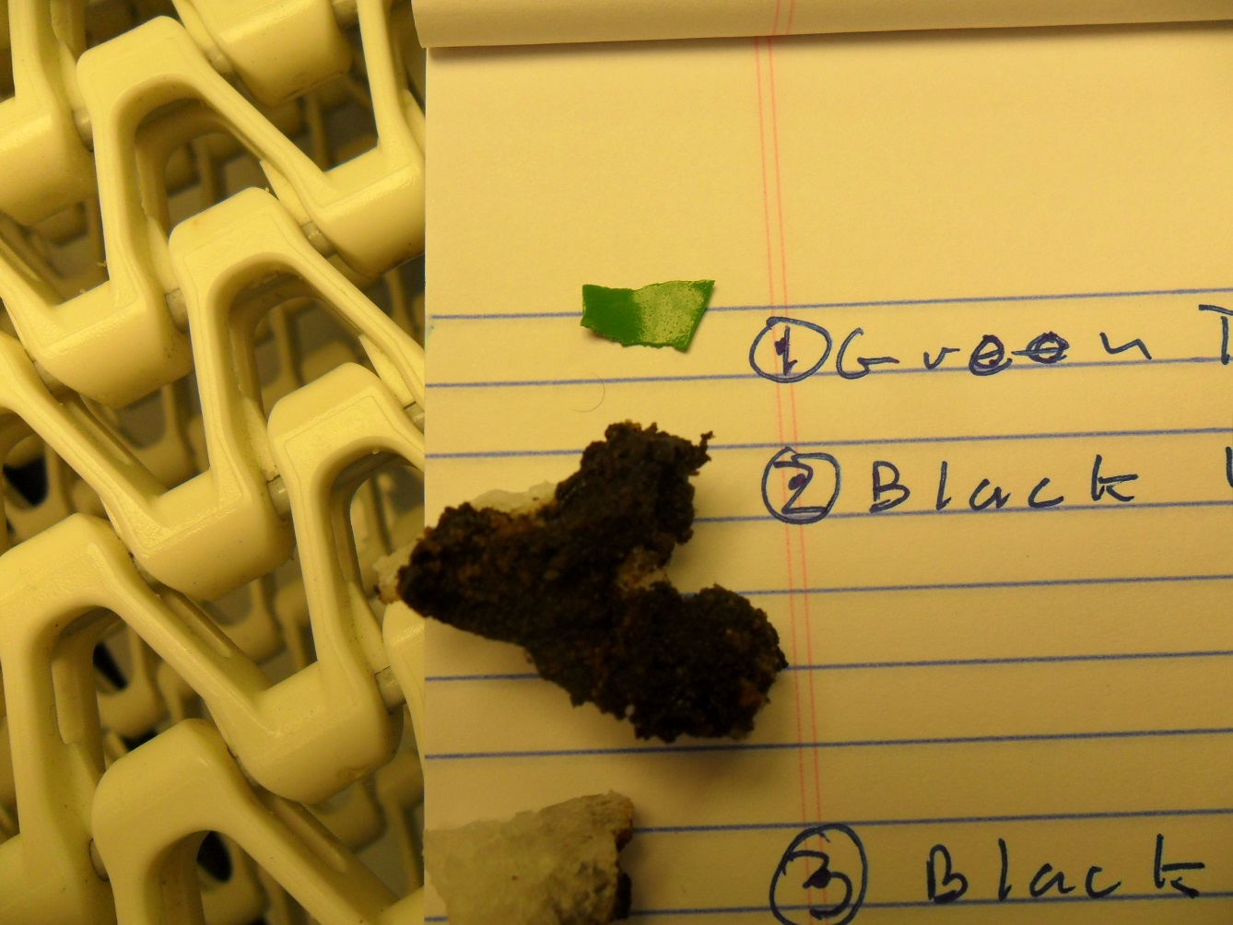

Figure 7. Typical Defect Particles

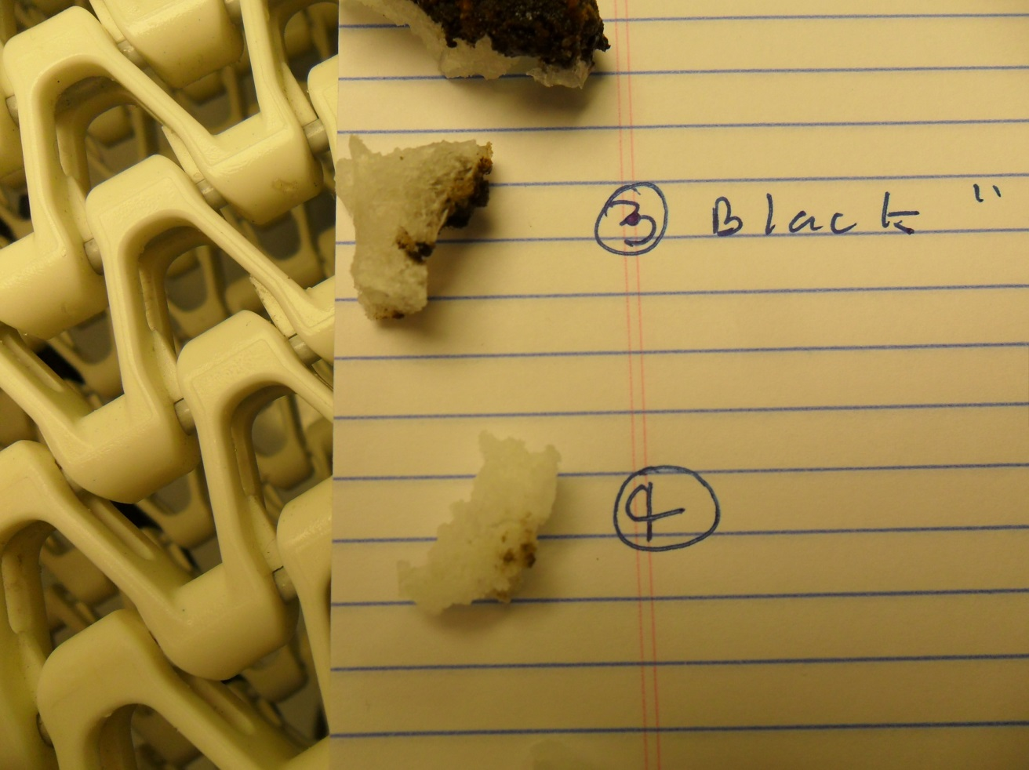

Figure 8. Typical Defect Particles.

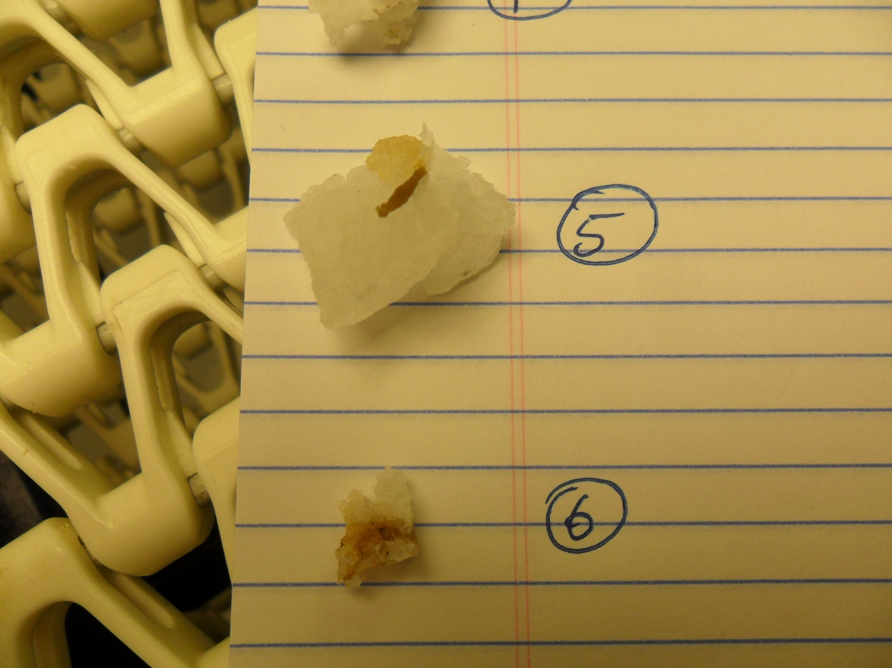

Figure 9. Typical Defect Particles.

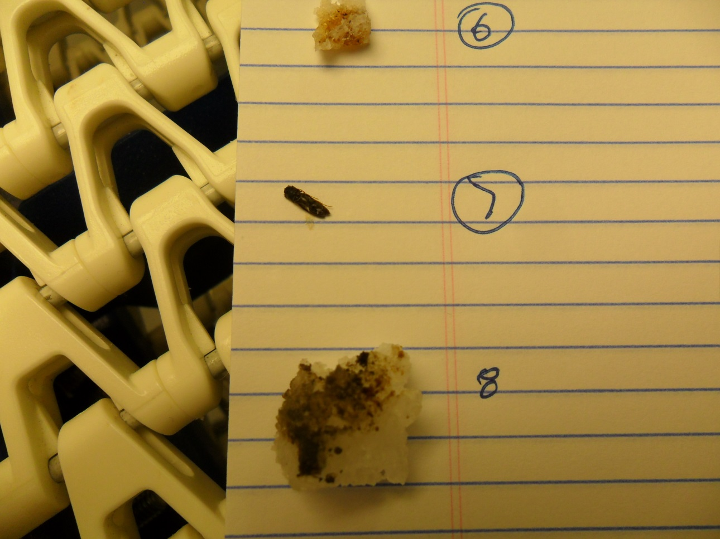

Figure 10. Typical Defect Particles.